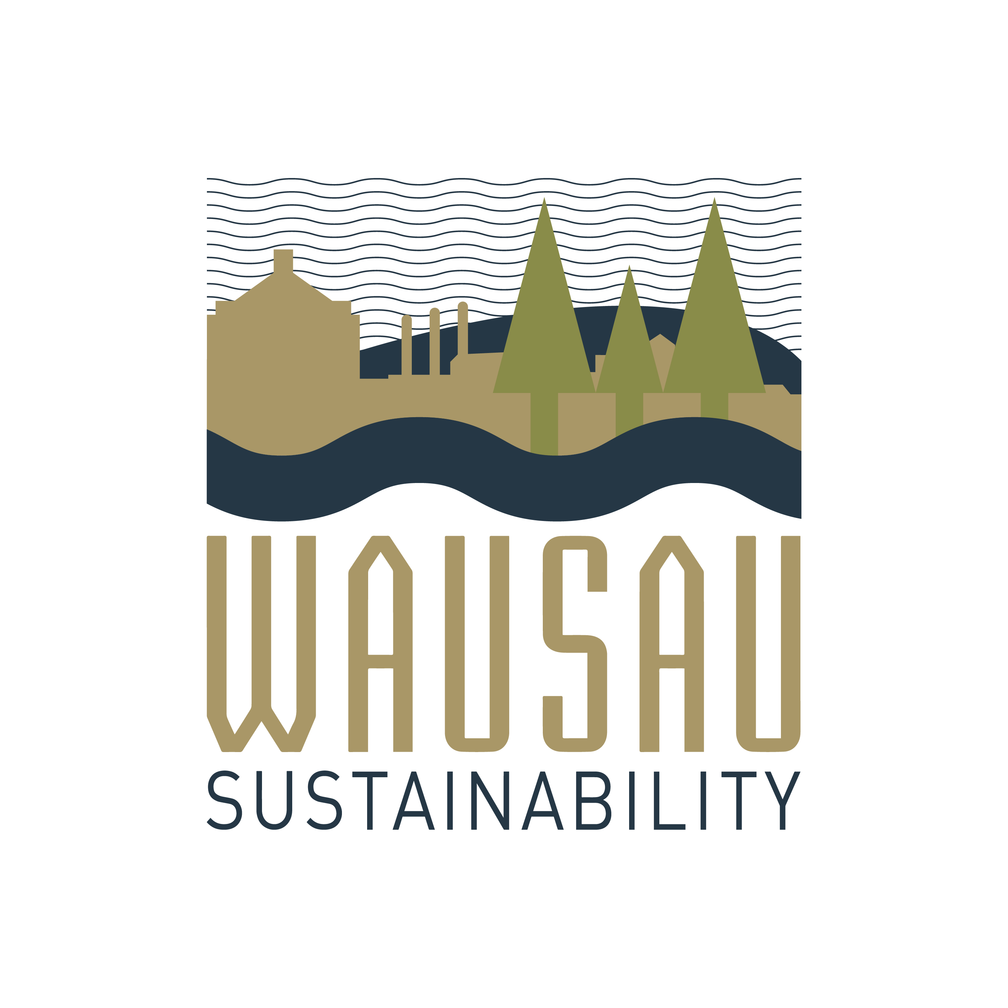

CITY OF WAUSAU

Presents this Certificate of Recognition
to
ASPIRUS HEALTH

as the recipient of the

WAUSAU SUSTAINABILITY AWARD
The Wausau Sustainability Committee is committed to investing and identifying sustainable initiatives and projects with businesses, residents, community groups and organizations within the Wausau community.
Thank you for your leadership and continued efforts to reduce energy consumption,
carbon emissions and energy costs and increase the use of renewables;
and now therefore, the
CITY OF WAUSAU
is pleased to provide this certificate on this 9th day of February, 2021.

_________________________________
Katie Rosenberg
Mayor, City of Wausau
February 9, 2021

